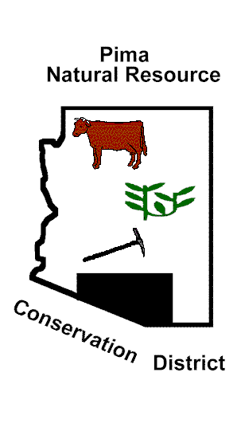
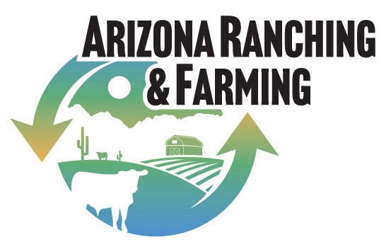
Pima Natural Resource Conservation District
Pima Center for Conservation Education
www.pimanrcd.org
www.azranchingfarming.org
Contact: clerk@pimanrcd.org

NOTICE OF COMBINED PUBLIC MEETING

Pursuant to A.R.S. § 38-431.02, notice is hereby given to the members of the Pima NRCD Board of Supervisors that the Pima NRCD Board of Supervisors/PCCE Board of Directors will hold a meeting open to the public at Micha’s Restaurant, 2908 S 4th Ave, Tucson, AZ 85713 at 1:00 pm on April 30, 2024.
As indicated in the agenda, pursuant to A.R.S. § 38-431.03(A)(1) and/or A.R.S. § 38-431.03(A)(2), the Pima NRCD Board of Supervisors may vote to go into executive session, which will not be open to the public.

PNRCD Draft Agenda for April 30, 2024
- Call to Order & Pledge of Allegiance
- Roll Call & Introductions
- Approve August 21, 2023 Minutes
- Approve Invoices (Supervisors & Clerk)
- PNRCD & PCCE Financial Reports
a. Annual reports to AZ Corporation Commission
- Agency Reports
a. NRCS
b. Other
- Call to the Public

- Old Business
a. Election Update – clerk
b. Fiscal year 2023 AACD dues
c. Report on AZ House Bill 2865
d. Update: Lawsuit against Forest Service and Fish and Wildlife Service
d. Updating Cooperator list and contact list – Supervisor Coping

- New Business — Local Work Group Meeting
a. Overview - Alisha Phipps
b. Review proposals for conservation projects for FY 2024 and FY 2025
i. Water System for Rancho Seco Ranch
ii. Assistance to Native Seed
iii. Altar Valley Conservation Alliance projects and funding
c. Plan and budget for specific conservation projects for FY 2025
d. Develop schedule of goals for FY 2025
e. Create a complete budget for PimaNRCD for FY 2025
i. Discussion/action: Determine a level of self-funding to be budgeted annually
- Update Long Range Plan and Conservation Strategy
- Supervisor Reports
PCCE Draft Agenda for April 30, 2024
- Discuss Ed Center funds that must be spent by June 30, 2024
a. Discussion/Action – proposal to open a brokerage account for the Ed Center
- Discuss/Approve FY 2024 Ed Center project: Convene a collaborative discussion with academics and agency personnel or hold a seminar about what the land grant universities are producing now and redirect them to meet the need for an educated labor supply in the animal husbandry sciences, livestock nutrition, large animal veterinary and range management fields in the private and public sectors in the not-too-distant future for Arizona agriculture.
- Develop a budget for FY for the Ed Center
i. NRCWAY-Environthon contribution
- Proposed Next Meeting Date: July 23, 2024
- Adjourn
Dated this day of April 29, 2024 by Liz Tuck (Pima NRCD Clerk)
Persons with a disability may request a reasonable accommodation, such as a sign language interpreter,
by contacting the district. Requests should be made as early as possible to arrange the accommodation.

